HEALTH BUDDY.

1Tilakraj R Revankar, 2Siddhant Chavan, 3Anisha Kumari, 4 Poorvika. P

*1UG Student Dept. Of CS&E, 2UG Student Dept. Of CS&E, 3Professor Dept. Of CS&E Presidency University, Bengaluru-560064*

1tilakrajrevankar28@gmail.com, siddhantchavan3114@gmail.com, [poorvikanayak2004@gmail.com,anishajha024@gmail.com](mailto:poorvikanayak2004@gmail.com,anishajha024@gmail.com)

**Abstract***-* **In a fast-paced modern world, maintaining optimal health through proper nutrition and hydration is often neglected. This paper introduces *Health Buddy*, a comprehensive application designed to address these challenges. The app employs a trained machine learning model to analyze users’ dietary inputs, predict nutritional content (vitamins, proteins, and calories), and track physical activities and hydration. Over time, it identifies potential nutrient deficiencies and suggests ways to mitigate them, preventing health risks associated with imbalances. Health Buddy also integrates habit-forming techniques, reminders, and data visualization to encourage consistent health management. This study discusses the app’s methodology, features, implementation, and the potential impact on personalized healthcare.**

**INTRODUCTION:**

**1.1 Health and Lifestyle Verse the Labs Life -** The Balance of Diet and Hydration

Foods and water are easy to forget in the modern fast-tempo and stressful life. Nutrition and waters have little hope when priorities hit a hectic pace, usually upsetting nutrition, making it less than desirable in many ways. Oftentimes, disregard for personal health leads to other conditions that may very well lead to long-lasting diseases such as obesity, diabetes, and heart disease.

**1.2 Being Unaware of Nutrient Deficiency**

Though most people are quite aware of their physical demands, they have hardly an idea about which vitamins and nutrients they are consuming or are deficient in their daily diet. Although micronutrient deficiencies, such as deficiency of vitamin D, calcium, iron, etc., usually go unnoticed until other more severe health issues arise, such is the case with bone density loss, extreme fatigue, etc. The absence of such tracking makes it rather challenging for that person to ensure a well-balanced diet feasible without guidance to meet nutritional needs.

**1.3 Difficulty Knowing Dehydration and Physical Activity**

Various work pressures and lifestyles develop an environment in which monitoring hydration levels and physical activity maintenance becomes a major issue. Physical fitness can very rarely be discussed. The requisite exercise and drinking of sufficient water are important parts of one’s health, but many times the person will forget this fact along with many other such things in their pulling schedules. Such laziness breeds further complications: easy behaviors bring on deficiencies, inactivity, and dehydration, which per se will facilitate healthy living.

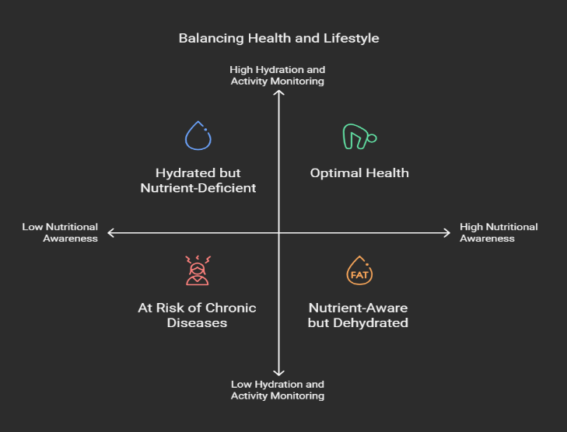

LITERATURE REVIEW:

**1. Personalized Dietary Advisories**

Viewers have more personalized recommendations for diets with an application of machine learning in nutrition tracking and health. Programs described in this manner by Espinosa et al. (2016) support tracking dietary intake on a mobile health app while providing unsolicited feedback. In using food diaries to obtain data collection and the relative information from some food-disposal devices, these systems get the users feedback relating to their own nutritional habits and deficiencies. This study has elucidated the way ML models take vast datasets and detect patterns in user behavior and suggest proactive health recommendations.

**2. Dietary Support Systems on the Basis of Health Conditions**

Some chronic diseases like diabetes and cardiovascular ailments require unique or specific dietary plans. A good example in this direction is the "Diabetic Buddy" system as described by Borle et al. (2020); it is using a different personalized ML algorithm to monitor and control dietary intake within diabetic patients. The system uses real-time blood sugar figures incorporated with food consumption data, which are the basis for recommendations on glycemic control and nutrition adequacy. Systems based on ML like this can reduce the burden on the users by automating monitoring and making other suggestions based on the health profile.

**3. Nutrition Estimation from Images**

Estimating nutrition from food images constitutes a promising aspect of ML investigations. The method entails the training of deep learning models on the datasets containing food pictures to predict their nutritional composition. For instance, a research paper by Yanai et al. describes systems unfolding information from multiple food image datasets, estimating calories, macronutrients, and vitamins from photos. Such an application could make a substantive difference in dietary self-reporting by lessening the need for individuals to record everything manually about their intakes.

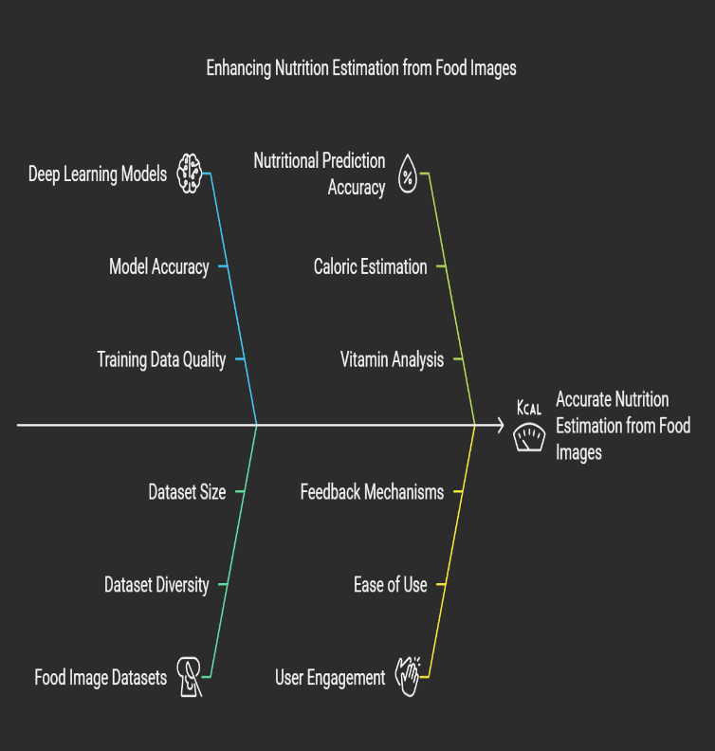

RESEARCH GAP

**1. Lack of Deep Personalization**

**Issue:** Most health applications provide general advice, tips, and health tracking. They do not take into account individual variations, such as medical history, lifestyle, genetic predispositions, or specific goals.

**Impact:** Users may not find the recommendations relevant to their specific conditions, hence they are less likely to engage with the application.

**2. Inconsistent Data Integration**

**Issue:** Integration of data from sources such as wearables, e.g., Fitbit and Apple Watch, or EHRs and other health monitoring devices.

**Impact:** Users may need to input data manually or juggle several apps, which can be inconvenient and might result in incomplete or even wrong health tracking.

**3. Privacy and Security Issues**

**Issue:** Health apps gather sensitive information regarding personal health, and inadequate security measures can endanger the data. Common problems include poor encryption, lack of user control over data, or confidentiality breaches.

**Impact:** Users may be reluctant to use the app or provide the accurate data due to concerns over privacy, and security problems could lead to legal and trust issues.

**4. User Engagement and Retention**

**Issue:** Many health apps are unable to retain users over time. Users may find the application hard to use, not engaging, or not motivational enough to continue their health goals.

**Impact:** Poor user retention can cause a high churn rate and thus reduce the long-term impact of the app on health outcomes.

**5. Overwhelming or Complex UI/UX**

**Issue:** UI and UX that are cumbersome or too complicated can result in health apps being burdensome to use.

**Impact:** Users may give up on a health app if it is too hard or too complicated to use, which defeats its purpose of helping them achieve desired health outcomes.

**6. Lack of Interactivity with Healthcare Providers**

**Issue:** Some health applications are only about self-care and do not connect them to healthcare professionals.

**Impact:** Users may get misleading advice or miss significant health signs that need medical attention. They will not be able to fully benefit from the application without discussing their health condition with their healthcare providers.

**7. Not Flexible Enough for Chronic or Specific Conditions**

**Issue:** Apps generally do not offer sufficient assistance to chronic patients or individuals with specific health issues like diabetes, hypertension, or mental disorders.

**Impact:** This constraint makes the utility of the app less attractive to those who need such specialized care and constant attention.

**8. Lack of Behavioral Science Integration or Habit Formation**

**Issue:** Majority health applications do not utilize behavioral science techniques to facilitate users in developing habitual behavior patterns. They usually do not provide support with gradual changes in behavior and positive reinforcement or goal establishment.

**Impact:** Their users might not be motivated enough to continue their adherence to health-related goals or wellness activities.

**9. Connectivity and Accessibility Issues**

**Issue:** Health apps that need constant internet connectivity or consume a lot of data are problematic for users in low-connectivity areas or those with limited data plans.

**Impact:** The user will not be able to access the app when needed, which can reduce its effectiveness, especially in emergencies or rural areas.

**10. Monetization and Accessibility**

**Issue:** Many applications use subscription-based models, advertisements, and in-app purchases, making it inaccessible for some people who cannot afford it.

**Impact:** Excludes particular groups of users because they do not have the financial capabilities to afford the application and it defeats the purpose of offering health support to everyone.

**PROPOSED MOTHODOLOGY**

**1. Advanced Personalization**

**Methodology:** This will use AI and machine learning to personalize recommendations based on individual user data such as medical history, lifestyle, age, gender, genetic predispositions, and specific health goals.

**Features:**

- Customized health and fitness plans for individuals.

- Adapt-algorithms which, learning from user feedbacks and behaviors, finely tune recommendations.

- The possibility of setting personalized reminders for medications, exercises, or hydration, depending on user habits.

**2. Strong Privacy and Safety Measures**

**Methodology:** State-of-the-art data encryption, anonymization, and compliance to regulations like HIPAA or GDPR for user information protection.

**Features:**

- MFA for login and data access.

- Transparency for the user to have control over data-sharing preferences and the ability to delete it once and for all.

- Regular audits of the application to ensure its proper security against new threats.

**4. Clean UI/UX**

**Methodology:** An interface with little navigating and artistic touch designs should make tracking the health metrics easier.

**Features:**

- Custom dashboards having the option of choosing on which metrics to display.

- Dark mode and accessibility options making the application friendly to users with visual impairment.

- Minimalist approach towards application design, thereby avoiding overwhelming the user with tons of features at once.

**5. Habit formation based on behavioral science**

**Methodology:** Behavioral science principles are applied here to assist users in building sustainable health habits.

**Features:**

Gradual setting of goals and forming habits based on user's readiness and motivation.

Positive reinforcement, with rewards implemented when users achieve small increments of progress toward larger health goals.

Customized habit-tracking tools that help monitor nutrition, exercise, sleep, or mindfulness on a day-to-day basis.

**OBJECTIVES**

**1. Health Monitoring:**

Users are able to measure various health metrics, such as physical activity, heart rate, and other vital signs, to gain insight into their health status.

**2. Personalized Recommendations:**

These personalized recommendations on diet, exercise, and lifestyle changes depend upon the user's health data, preferences, and goals.

**3. Habit Tracking:**

It will track users and progress on their ways towards regular exercise, balanced eating habits or giving up smoking while sending them reminders.

**4. Goal Setting and Progress Tracking:**

The users set health goals and monitor their process through visual aids, like graphs or progress bars.

**5. Alerts and Reminders:**

Users will be notified about the tasks related to health such as intake of medications, or completion of goals for that day.

**6. Data Security and Privacy:**

User health data is stored confidentially and protected whilst giving users access to sharing options and privacy settings.

SYSTEM IMPLEMENTATION:

**1. System Architecture**

Health Buddy is designed with a modular architecture to ensure scalability, flexibility, and maintainability. The key components of the system include:

**User Interface (UI)**: A user-friendly mobile application developed using Flutter and Dart, ensuring cross-platform compatibility (iOS and Android). The development is conducted in Android Studio.

**Backend Server**: A robust backend server developed responsible for handling data storage, processing requests, and interacting with the machine learning model.

**2. Data Collection and Preprocessing**

**Dietary Input**: Users input their daily food intake through the mobile app. The input can be in the form of text, voice, or images. Natural Language Processing (NLP) techniques are used to parse text and voice inputs, while image recognition algorithms analyze food images.

**Activity and Hydration Logging**: Users manually log their physical activities and hydration levels. The app can also integrate with wearable devices and fitness trackers to automate data collection.

**Preprocessing**: The collected data is preprocessed to ensure consistency and accuracy. This includes data cleaning, normalization, and transformation.

**3. Nutritional Analysis**

**Model Training**: The machine learning model is trained on a comprehensive dataset of food items and their nutritional content. The dataset includes information on vitamins, proteins, calories, and other essential nutrients.

**Prediction**: The trained model predicts the nutritional content of the user’s dietary inputs. The predictions are stored in the database for further analysis.

**4. Deficiency Identification and Recommendations**

**Nutrient Deficiency Analysis**: The app continuously monitors users’ nutritional intake and compares it against recommended daily allowances. The machine learning model identifies potential nutrient deficiencies over time.

**Personalized Recommendations**: Based on the identified deficiencies, the app provides personalized recommendations to mitigate potential health risks. These recommendations include dietary adjustments, supplement suggestions, and lifestyle changes.

**5. Habit Formation and Reminders**

**Habit-Forming Techniques**: The app incorporates behavior change techniques, such as goal setting, progress tracking, and positive reinforcement, to encourage healthy habits.

**Reminders and Notifications**: Users receive timely reminders and notifications to log their dietary intake, physical activities, and hydration levels. The app uses push notifications and in-app alerts to ensure user engagement.

**6. Data Visualization**

**Visual Dashboard**: Health Buddy features a visual dashboard that presents users with a comprehensive overview of their health data. The dashboard includes charts, graphs, and summary statistics to make data interpretation easy.

**Progress Tracking**: Users can track their progress over time, view trends, and set health goals. The visual representation of data helps users stay motivated and informed.

**7. Integration of Chatbot**

**Chatbot Integration**: Health Buddy includes a chatbot feature to provide users with real-time assistance and support. The chatbot is powered by a machine learning model and integrated using an API key. It helps users with dietary suggestions, answers health-related queries, and provides motivational support.

**API Key Management**: The API key for the chatbot is securely stored and managed within the backend server. The chatbot communicates with the backend to fetch necessary information and provide responses to user queries.

RESULT AND DISCUSSION:

Track progress toward your nutrition, water, fitness, and weight loss goals with MyFitnessPal. This all-in-one food tracker and health app is like having a nutrition coach, meal planner, and food diary with you at all times.

SO MUCH MORE THAN A CALORIE TRACKER & FOOD JOURNAL

It’s like having a dietitian, personal trainer, and nutrition coach at your fingertips.

**Log Food** – Easy-to-use tools make food tracking quick and simple

**Record Activity** – Add workouts and steps with the fitness tracker

**Customize Your Goals** – Weight loss, weight gain, weight maintenance, nutrition & fitness

**See Your Progress** – Track at a glance, or analyze nutrition & calories in detail

**Learn From a Registered Dietitian** – Meal Plans customized for your target calories, whether you want to lose or gain weight—with access to our Meal Planner tool .

**Stay Inspired** – 500+ healthy goal-focused recipes and 50 workouts keep routines fresh and fun.

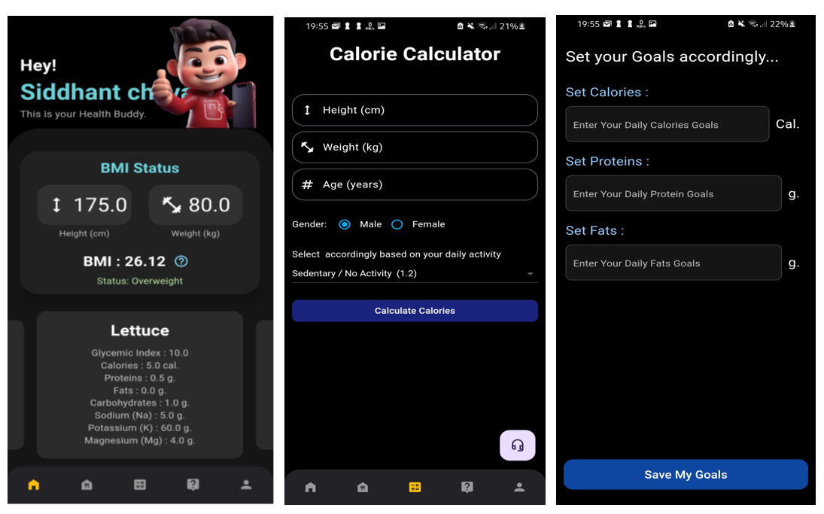

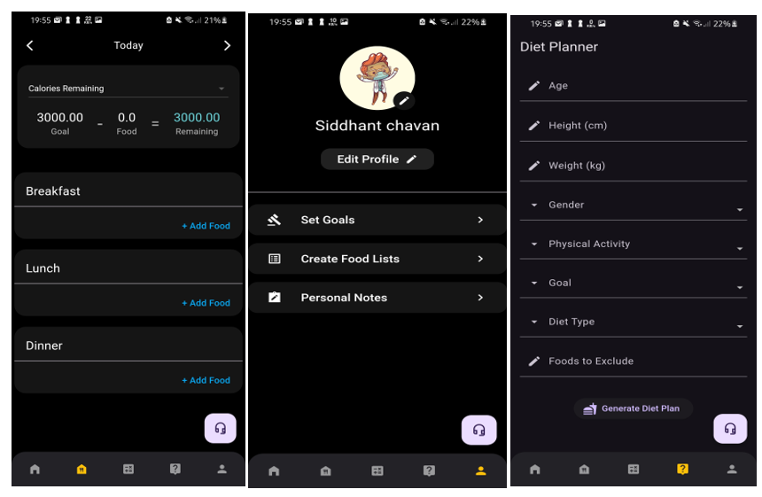

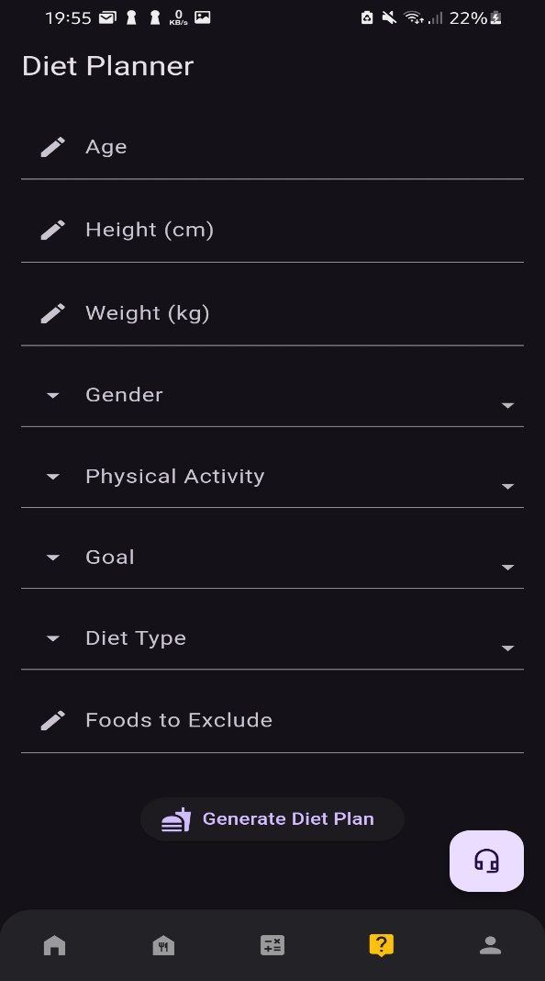CONCLUSION:

This study evaluated the quality and effectiveness of popular calorie-counting apps in weight management and behavior change. The top 20 apps from the Google Play Store were assessed using a 55-point scale based on standards, content accuracy, user interface, and database sources, with a mean quality score of 36.95 ± 5.65. Over 65% of the apps miscalculated calorie intake. To test effectiveness, 60 young volunteers were divided into an intervention group (n=30), using top apps for 8 weeks, and a control group (n=28). While no significant changes in anthropometry or diet were observed, the intervention group showed a 13.33% increase in physical activity.

REFERENCE :

**Research Papers:**

• https://mhealth.jmir.org/2016/3/e85/

•https://www.researchgate.net/publication/364083577_Nutrition_information_estimation_from_food_photos_using_machine_learning_based_on_multiple_datasets

• https://www.ncbi.nlm.nih.gov/pmc/articles/PMC5499922/

• https://www.ncbi.nlm.nih.gov/pmc/articles/PMC9776646/

• https://www.ijraset.com/research-paper/vitamin-deficiency-and-food-recommendationsystem-using-ml

•https://www.researchgate.net/publication/348403597_The_Diabetic_Buddy_A_Diet_Regulator_andTracking_System_for_Diabetics

• https://www.ncbi.nlm.nih.gov/pmc/articles/PMC7551874/

• https://www.sciencedirect.com/science/article/pii/B9780124095472143124

• https://www.sciencedirect.com/science/article/pii/B9780124095472143148

• https://www.sciencedirect.com/science/article/pii/B9780123848628000091

• https://www.healthyfamiliesbc.ca/sites/hfbcprox-prod.health.gov.bc.ca/files/restaurant_info/guide-to-nutrient-analysis.pdf

**Dataset:**

•https://www.kaggle.com/datasets/utsavdey1410/food-nutrition-dataset

• <https://www.researchgate.net/figure/Assessment-of-quality-of-calorie-countingapps-using-summarised-scoring-scale_tbl1_333777044>